**Following parameters are to be considered for exercise submission:**

1. **The complete project has to be submitted.**
2. **.idea, target directories should be excluded**
3. **A text file containing the relevant URLs which are referenced and any other documentation.**

MAVEN

1.https://programmingtechie.com/2020/12/05/complete-maven-tutorial/

2.https://maven.apache.org/index.html

**Questions:**

1. **Add a maven dependency and its related repository URL.**

<dependency>

<groupId>junit</groupId>

<artifactId>junit</artifactId>

<version>4.13</version>

<!--This scope indicates that the dependency is only available for

the test compilation and execution phases. -->

<scope>test</scope>

</dependency>

1. **Add a new repository in the pom.xml and use its dependencies.**

<repositories>

<repository>

<id>junit repo</id>

<url>https://mvnrepository.com/artifact/junit/junit/4.13</url>

</repository>

</repositories>

1. **Using JAR plugin, make changes in the pom.xml to make the jar executable. Using java -jar JAR_NAME, the output should be printed as "Hello World".**

<build>

<plugins>

<plugin>

<!-- Build an executable JAR -->

<groupId>org.apache.maven.plugins</groupId>

<artifactId>maven-jar-plugin</artifactId>

<version>2.4</version>

<configuration>

<archive>

<manifest>

<mainClass>HelloWorld</mainClass>

</manifest>

</archive>

</configuration>

</plugin>

</plugins>

</build>

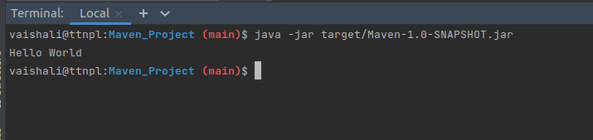

1. **Differentiate between the different dependency scopes: compile, runtime, test, provided using different dependencies being defined in your pom.xml.**

<dependencies>

<dependency>

<groupId>junit</groupId>

<artifactId>junit</artifactId>

<version>4.13</version>

<!--This scope indicates that the dependency is only available for

the test compilation and execution phases. -->

<scope>test</scope>

</dependency>

<dependency>

<groupId>javax.servlet</groupId>

<artifactId>servlet-api</artifactId>

<version>2.5</version>

<!-- This scope indicates that dependency is not required for compilation,

but is required during execution. -->

<scope>provided</scope>

</dependency>

<dependency>

<groupId>mysql</groupId>

<artifactId>mysql-connector-java</artifactId>

<version>8.0.17</version>

<!--This scope indicates that dependency is not required for compilation,

but is required during execution. -->

<scope>runtime</scope>

</dependency>

<dependency>

<groupId>junit</groupId>

<artifactId>junit</artifactId>

<version>4.13</version>

<!-- This scope indicates that dependency is available

in classpath of project. It is default scope.-->

<scope>compile</scope>

</dependency>

</dependencies>

1. **Create a multi-module project. Run the package command at the top level to make a jar of every module.**

After creating 2 modules and updating their src with parent

$mvn clean install

<modules>

<module>Child1</module>

<module>Child2</module>

</modules>

$mvn package

